Attachment 3: KDOL UI System Integrations & Conceptual Data Model
KDOL UI System Integrations
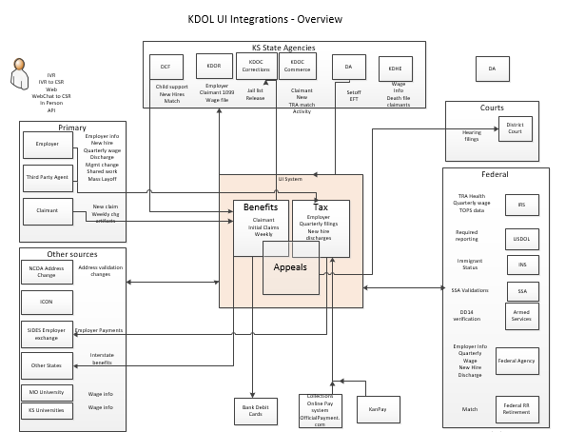

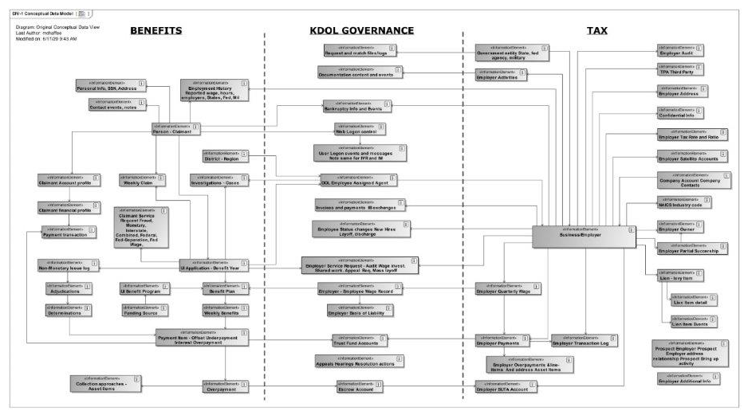
KDOL UI Systems Conceptual Data Model for Benefits & Tax

